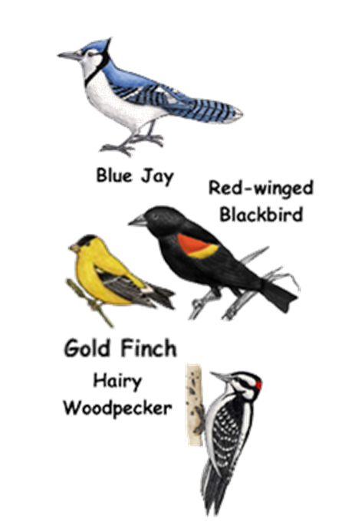

**Today at NDOG Kidz Klub**!

**Making bird feeders!**

**Making bird feeders with your kids is a great way to get to know the birds in your area and to get the kids (and you!) into the garden! Today the kids will make several different feeders to take home to attract the birds!**

**Each week, 8am – 9:30am, May 12 – August 11, NDOG volunteers will provide fun crafts and learning activities to children ages 3 – 10. Visit the garden during market hours for more information or contact Sherry Wenta at (870) 845-0134.**

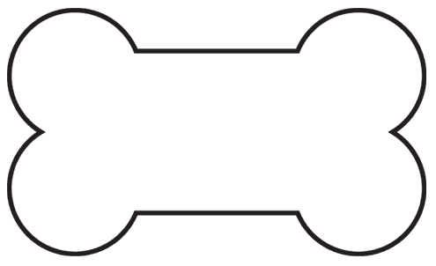

**Kidz Klub**



